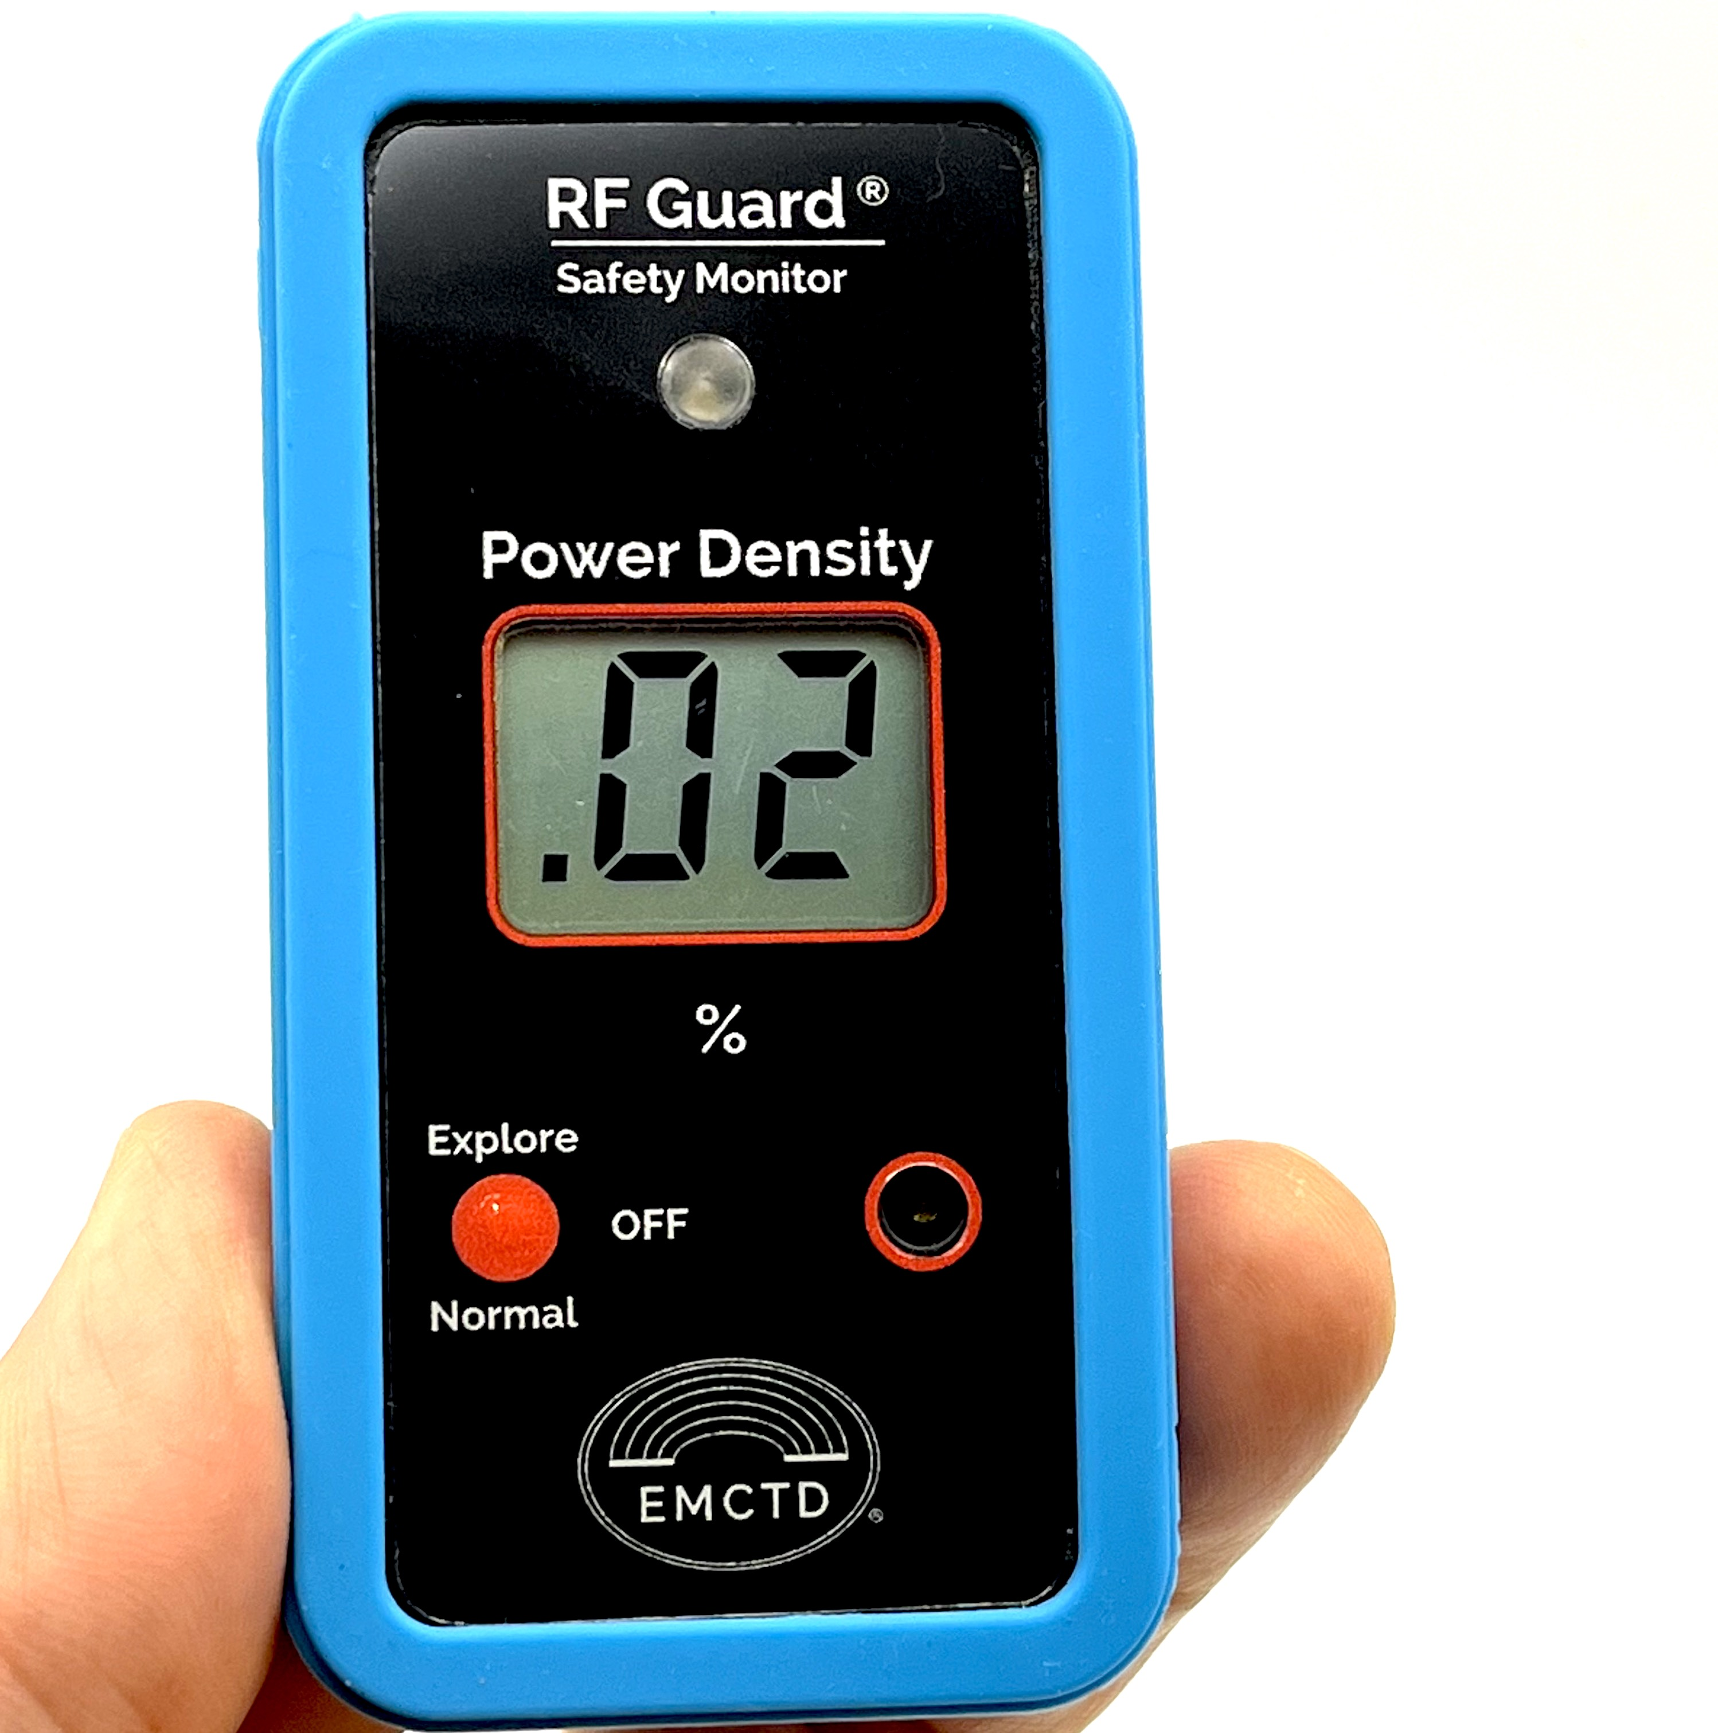

**Guard® Pro**

**Guard® Pro** is a simple, compact field strength monitor that allows me to detect and evaluate the presence of strong RF sources around me, providing peace of mind and ensuring RF safety. I can always have this unit with me, paying no attention to its operation. If I get into a high-RF field strength area, it will notify me properly.

I can also explore my environment, locate and evaluate all strong RF sources, and mitigate their potential harm.

**How to use Guard® Pro?**

- Push the red button once. The unit will play ascending sound and turn on the two-digit LCD that will show software revision, coin battery voltage, and average power density in %. Your **Guard® Pro**is in Normal Mode and ready for use.

- **Guard® Pro** consumes very little power, so once it is turned on, it may stay on for many months unless you want to use the installed coin battery for years by shutting it down when not in use.

- The display will show a reading of about 0.01% when there is no measurable RF field, increasing to 99% at the FCC/ICNIRP safety level for the general public (100% equals 1mW/cm2). If power density increases, the reading will increase in the following steps (in %): 111, 211, 311, 411, 511, and then—HI, indicating an overload. The level 500% equals 5mW/cm2 is the FCC/ICNIRP safety level for occupational personnel.

In **Normal mode (Average)**, the unit performs the power averaging with a SLOW time constant of about 1 sec, producing the RMS (root mean square) values of the power density level.

- Besides the display reading, the color LED will turn on Green-Yellow-Red when the average RF power density crosses 0.1%, 1%, and 10%.

- A sound alarm will sound when the display reading exceeds 1%. If the display reading is higher than 10%, the alarm intensity will rise, alerting about the high fields. If the display reading exceeds 100%, the sound alarm changes the pattern to a dual beep to provide a notification.

- If the unit detects relatively high RF fields, you may be interested in finding their source. To do that, push the red button for the second time. The unit will switch into **Explore mode (Peak)** with a blinking display and LED. In this mode, the display shows the peak power density level, measured with a FAST time constant of about 40 usec, capturing the pulsed RF signals. To measure the peak power density of digital communication sources, Explore mode uses the S/H (Sample and Hold) feature with S/H times 10 usec./1 sec., allowing the display to show the peak power density values in real-time.

LED detects the RF field spikes typical for cellphone and Wi-Fi operation. The speaker produces level-dependent sounds with the same thresholds as in Normal mode, allowing you to quickly find the origin of intense RF radiation and measure its peak power density. Play with it, and you will quickly learn how it works.

- Push the button for the third time, and the unit will switch to the **Explore mode (Peak/Hold).** In this mode, the peak power density's maximum value is frozen and updated for as long as this mode is active.

- The unit consumes much higher power in Explore (Peak) and Explore (Peak/Hold) modes, so after 2 minutes, it will automatically return to Normal Mode. You can switch back to Normal Mode anytime by pushing the red button.

- The unit will turn off entirely if you make a long 3-second push. This is accompanied by a descending sound indicating that the unit is OFF.

- The battery's lifetime in a benign electromagnetic environment is about 2,000 hours. The battery must be replaced if you see **two blinking dots** instead of numbers. The CR2032 coin cell battery can be purchased from most stores.

**How to carry and hold Guard® Pro?**

- RF Guard® Pro has a built-in dual antenna that detects RF fields from the unit's back (and, to a lesser degree, from the front). So, when you hold the unit with the display towards you, it will measure the RF fields from the sources located primarily in front of you.

- Placing the unit in your front shirt pocket may be convenient, but remember that the human body absorbs RF radiation, and the readings will be lower.

- When holding the unit, keep your fingers at the lower part of the **Guard® Pro**body (below the display) to avoid shielding the antennas.

- Keep the Guard® Pro away from metal conductive surfaces—they create undesirable resonances that may affect the readings.

**What does the Guard® Pro reading mean?**

- The Guard® Pro display always shows the RF radiation power density and is calibrated to show a 100% reading corresponding to 1 mW/cm2 at 2.45 GHz. But what does it mean?

- The RF safety standards we use today were created by the end of the last century to protect people from the detrimental effects of the strong RF fields, mainly - radars and powerful RF transmitters. The primary health effect of the radiation that was taken into account was - thermal heating. The magic number of 1mW/cm2 approximately corresponds to the human tissue heating of 1°**C.** So, based on that definition, 100% reading is unsafe and should be avoided.

- But are the lower levels safe? If you have a reading of 10%, that will correspond to the heating of 0.1°C (heating scales with absorbed power) and should be safe. Unfortunately, modern RF signals are digitally modulated, and their peak RF power is not only many times higher than their average power (which is the same for the radar signals), but the envelope of the RF signal contains many frequencies that can interfere with various electrophysical processes in the human body. To simplify it, a vast amount of knowledge today proves that, in some cases, even "safe" RF power levels may be unsafe for some people. Unsafety of these situations may not necessarily be linked to permanent damage but may instead cause human functional health disorders. This is even more true for a small number of people with so-called "RF Hypersensitivity."

- This is why we created the Guard® Pro: We wanted to give you the measuring device to exercise the Precautionary Principle: "The lower the level of RF radiation, the better." Please see the table below for reference.

**Levels here are measured in Normal mode and represent the Average power density.**

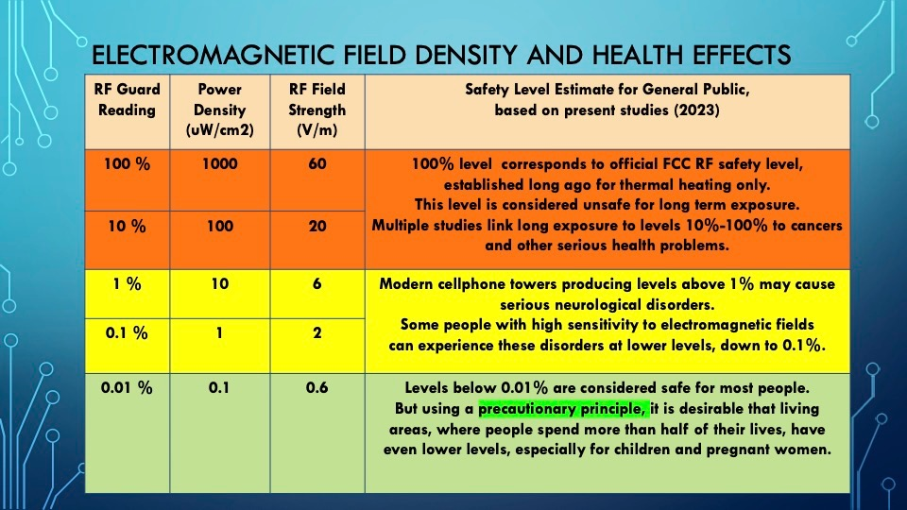

**Disclaimer:**

Every Guard® Pro unit has been calibrated at one frequency of 2.45 GHz, and we post a typical frequency response in the frequency range 30 MHz-60 GHz, taken in the test lab with a reference unit matching the current production one. The frequency response is neither flat nor compliant with the FCC/ICNIRP-shaped probe curve. This means that while having an ultrawide detection frequency range, at some frequencies, it will show higher levels and some lower levels than in reality. This is the drawback of the technology used and should be expected from relatively inexpensive consumer products with built-in antennas. If you happen to be in a situation where Guard® Pro in Normal mode repeatedly reads high RF levels (10-100 %) or even levels higher than 100%, you should try to leave that area and consult a licensed RF safety professional who will analyze your particular situation with professional-grade test instruments. EMC Test Design, LLC cannot be responsible for any damages resulting from such applications.

**How to take care of Guard® Pro?**

- Keep Guard® Pro clean and dry. Do not expose it to rain or submerge it in water.

- Do not clean it with solid chemicals - use a damp cloth with a window washer.

- Dispose of the CR2032 battery properly. **Keep it out of the hands of small children(!).**

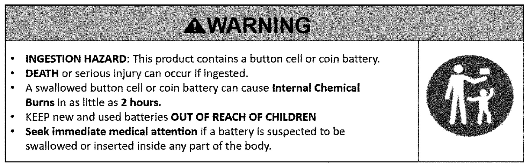

- Do not disassemble the unit - there are no user-serviceable parts inside.

- To replace the coin battery - slide down the battery cover and use a small screwdriver to pry the battery.

­

**Features Summary:**

• Designed to be carried by a user to detect, notify, and warn about the electromagnetic environment.

• Triple mode operation: **Normal** and **Explore (Peak) and Explore (Peak/Hold)**.

• In Normal mode (Slow) display and 3-color LED show the average power density level (in % of the standard safety level) with dual sound alarm turning on when the level exceeds 1% and 10%.

• In Explore (Peak) mode (Fast sampling and Slow decay) display shows peak power density level while 3-color LED and variable pitch sound indicate pulse signals for the RF source’s location and identification.

• In Explore (Peak/Hold) mode (Fast sampling and Frozen max reading), the display shows the maximum peak power density level, while a 3-color LED and variable-pitch sound indicate pulse signals for the RF source’s location and identification.

• Operation is controlled by a single button: Normal - Explore (Peak)- Explore (Peak/Hold) - Normal - (Long Push) OFF.

After 2 min., any Explore mode unit automatically returns to Normal mode to save the battery.

• The unit has a particular hole on the left side to allow for the hand strap lanyard attachment. A lanyard is included.

• The unit has premium nonslip sleeves for good hand grip and protection.

• Unit is sold in a custom carton box with a short User's Manual printed on insert inside.

**Technical parameters of Guard® Pro**

1. Frequency range: **30 MHz-60 GHz**.
2. Power density range Indication: **0.01%-500%.**
3. Corresponding field range: **0.6-137 V/m.**
4. RF safety standard level.
5. 100% corresponds to 1mW/cm2 @ 2.45 GHz, General Public limit.
6. 500% corresponds to 5mW/cm2 @ 2.45 GHz Occupational limit.
7. Battery life: 2,000 hours in a benign electromagnetic environment.
8. Dim. (in sleeve): 93x48x15mm; 3.7"x1.9"x0.6".
9. Weight: 60 g; 2 oz.
10. Operating Temperature Range: -5°**C** to +40°**C**.
11. Warranty 1 year.
12. **Designed and made in the USA.** EMC Test Design, Sarasota, FL 34233, USA.
13. 